**STATUS REPORT**

**TEAM 11**

**ACHIEVEMENTS**

**ISSUES**

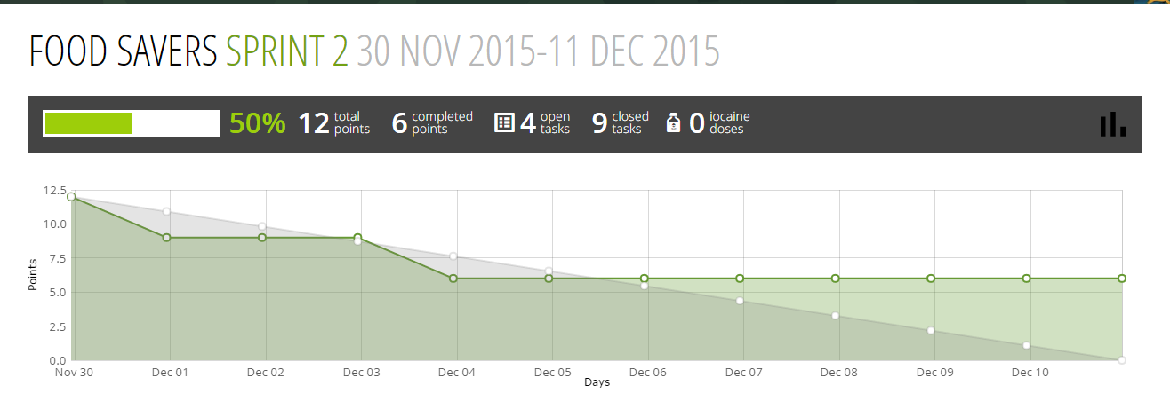

BURN DOWN CHART :

Tracking Down current progress with help of TAIGA Project Management tool..